Testing Results

This document showcases how the simplified test results look like. There are two forms; a table that shows the number of errors and a JSON document that is a summary of the test. In the second one, the tester can identify where he has to look in the full report.

Test 1
Table Results:
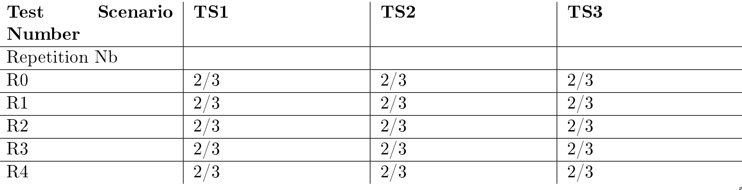

What to understand: 2 out of 3 request in each scenario failed. No difference due to repetition. I have to look at all of the scenarios in the full report to see what fails.

JSON Summary:
{
"NonExecutedActions":[],
"RepetitionDifference":false,
"PassedAllTests":["IncreaseTemp"],
"FailedAllTests":["ChangeFanSpeed","TurnOff"],
"HasSameErrorId": ["TurnOff"]
}

What to understand: No difference due to repetition. IncreaseTemp works fine. TurnOff fails with the same error id no matter the scenario so there is a more basic problem (maybe the uri is wrong). ChangeFanSpeed on the other has a specific problem for each scenario so I have to read the full report.

Test 2
Table Results:
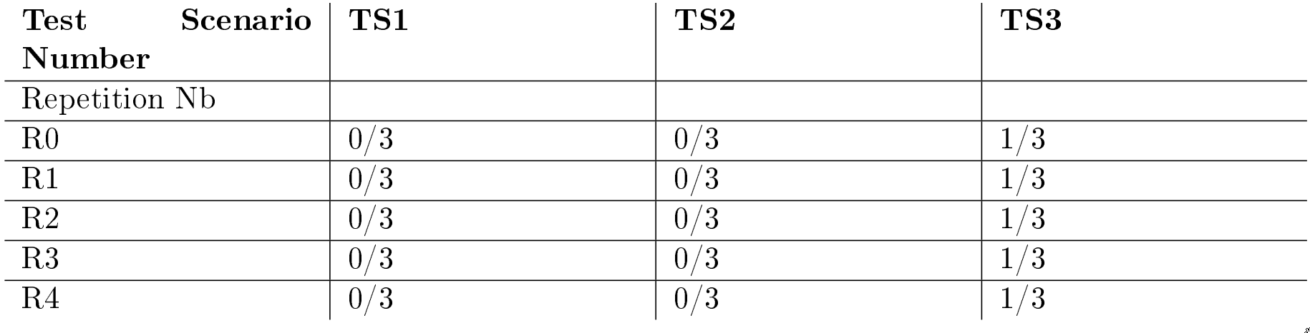

What to understand: 1 out of 3 requests in scenario 3 failed. No difference due to repetition. I have to look at scenario 3 to find what is wrong.

JSON Summary:
{
"NonExecutedActions":[],
"RepetitionDifference":false,
"PassedAllTests":["IncreaseTemp","ChangeFanSpeed"],
"FailedAllTests":[],
"HasSameErrorId": []
}

What to understand: No difference due to repetition. IncreaseTemp and ChangeFanSpeed work fine. TurnOff has a specific problem for some scenarios and not all like last time.

By combining the two I understand that I have to look precisely at scenario 3 and TurnOff request.

Test 3
Table Results:
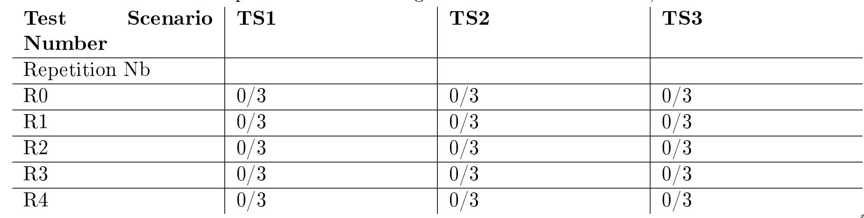

Everything works fine so no need to read anything.

